This Form was created in Word using VF Creator.
Created: 12/01/2018 by the VF Creator team.
VF Creator turns documents created in Word into online forms.

You can view/edit eForm features, after installing the VF Creator add-in. A new VF Creator ribbon will be available which allows you to create/edit eForms.

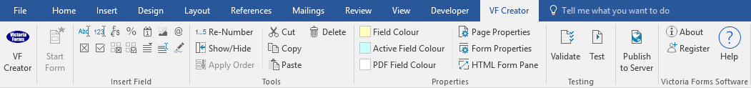

Please visit VictoriaForms.com/VF-Creator/ to start creating online forms in Word.

Full Reference Guarantor Form

Please return this form to VF Letting Agents. Asterisks (*) indicate a field is mandatory.
Agency Details
Letting Agent Name * | Letting Agent ID *

Property Details
Abode * | Building/House Number * | Building/House Name *
Address *
Town * | County * | Postcode *
Total Monthly Rent *

Guarantor Details
Name of Tenant (Who are acting for) * | Relationship with Tenant *

Guarantor's Contact Details
Title * | First Name * |  | Middle Name * |  | Last Name *
Previous Full Name (If your name has changed in the last 12 months)
Date of Birth * |  | Telephone Number * |  | Mobile Number *
Email Address *

Guarantor's Details
Marital Status * | Do you Smoke? * |  |  |  | Do you have Pets? * |  | Any recent Arrears or Adverse Credit?
 | Yes |  | No |  | Yes | No | Yes |  | No
Guarantor's Current Address Details
Abode * |  |  | Building/House Number * |  |  |  | Building/House Name *
Address *
Town * |  |  | County * |  |  |  | Postcode *
What is your current residency position? If 'Tenant', please complete the section titled 'Landlord / Agency Details' below.
Tenant |  | Owner |  | Live with Parents |  |  |  | Family/Friends

Landlord / Agency Details
Abode * |  | Building/House Number * | Building/House Name *
Address *
Town * |  | County * | Postcode *
Name of Landlord / Letting Agents *
Contact Email Address * |  |  | Telephone Number *
Title * | Contact First Name * |  | Contact Last Name *

Source of Income
Employed (PAYE) |  | Self-Employed | Investments/  Savings | Benefits | Other
Employer / Accountant Name * |  |  |  | Annual Income Amount *
Title * | Contact First Name * |  |  | Contact Last Name *
Contact Email * |  |  |  | Contact Telephone Number *
Comments / Further Information (if you have further income sources, please specify these on the next sheet)

Identification
National Insurance Number * | Identification Type |  | Identification Number *
Bank Account Number |  | Bank Account Sort Code

Declaration
I confirm that the information provided in this application form is true, accurate and complete. I understand that the information I have submitted will be used for assessing my suitability to be granted a tenancy agreement, or to be named on the tenancy agreement as a Guarantor, and I give my consent to the information I have provided being shared with third parties for this purpose. I understand and agree that current or former employers, landlords and letting agents may be asked to provide additional information about me or to verify information that I have provided. I understand that I may be refused a tenancy, or may be found unsuitable to act as a Guarantor, as a result of the searches and references obtained by VFRent Limited and I agree that I shall not seek to hold VFRent Limited liable for such refusal nor shall I seek to bring any claim against VFRent Limited for any loss or damage suffered by me as a result of such refusal. I understand that information which I provide or which is collected about me may be retained on file or stored electronically in accordance with the provisions of the Data Protection Act 1998.
Guarantor's Name * | Guarantor's Signature * | Date *

Additional Information
If you need to provide any previous addresses, names, credit history or other credentials please describe them below.

