This Form was created in Word using VF Creator.
Created: 01/02/2018 by the VF Creator team.
VF Creator turns documents created in Word into online forms.

You can view/edit eForm features, after installing the VF Creator add-in. A new VF Creator ribbon will be available which allows you to create/edit eForms.

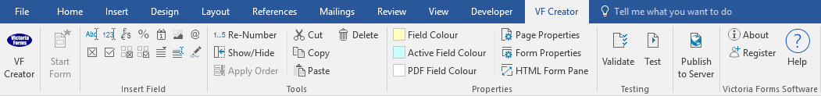

Please visit VictoriaForms.com/VF-Creator/ to start creating online forms in Word.

Applicant Evaluation

Applicant information
Candidate |  | Department
Position applied for |  | Interviewer

Candidate evaluation

Knowledge of specific job skills

Related job experience

Related education or training

Initiative

Communication/listening skills

Attitude

Interest in company/position

Strengths

Weaknesses

Additional comments

