This Form was created in Word using VF Creator.
Created: 12/01/2018 by the VF Creator team.
VF Creator turns documents created in Word into online forms.

You can view/edit eForm features, after installing the VF Creator add-in. A new VF Creator ribbon will be available which allows you to create/edit eForms.

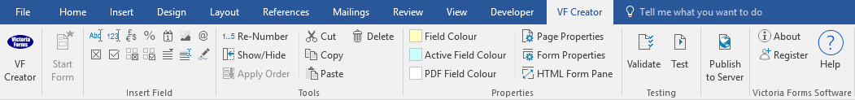

Please visit VictoriaForms.com/VF-Creator/ to start creating online forms in Word.

Sentry House
Northgate Business Park
Bury St Edmunds, Suffolk
IP33 1HP
01284 703000

VF Recruitment

Please complete the timesheet and submit by 2:00pm.

Employee Name: |  | Title:
Employee ID: |  | Employee Type:
Department: |  | Supervisor:

Date | Start Time |  | End Time | Regular Hrs. | Overtime Hrs. | Total Hrs.
 |  | WEEKLY TOTALS:

Declaration

I understand that I must submit a signed timesheet no later than 2:00p.m every Monday in order to get paid. I confirm I will total the hours correctly and deduct breaks.

Employee Signature: |  | Date:
Supervisor Signature: |  | Date:

Terms & conditions: Failure to submit your timesheet by the time stated above will delay your payment.

