This Form was created in Word using VF Creator.
Created: 12/01/2018 by the VF Creator team.
VF Creator turns documents created in Word into online forms.

You can view/edit eForm features, after installing the VF Creator add-in. A new VF Creator ribbon will be available which allows you to create/edit eForms.

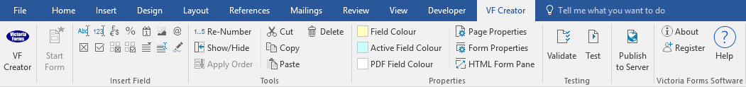

Please visit VictoriaForms.com/VF-Creator/ to start creating online forms in Word.

COMPLAINT FORM

- GENERAL INFORMATION
Please complete this form if you would like your complaint to be resolved by the VF Property Redress Scheme. Please ensure that:

- You have raised a formal complaint in writing with our Member;
- You have exhausted the Member’s internal complaints procedure;
- You have waited 8 weeks from the date of your formal written complaint for a response;
- It is within 6 months of your last correspondence from our Member.

A VF Property Redress Scheme Case Assessor will assess the complaint to ensure the complaint meets the criteria of the Scheme’s acceptance of complaints. We aim to inform you of the outcome of this assessment within 10 working days. We may be required to request further information or evidence from you.

- YOUR DETAILS:
Please provide us with your current contact details.

Name:
Correspondence Address:
Postcode
E-mail:
Telephone:
I am complaining as a: | Tenant  Buyer Landlord |  | Seller  Leaseholder Other
Address in relation to the complaint (if applicable)

- OUR MEMBER
Please insert the details of the Member you are complaining about.
Member Name
Member Number (obtain from the Member)
Name of person dealing with (if known):
Correspondence
Address:

Postcode
Telephone
E-mail

- THE COMPLAINT – (VF Pre-Property Redress Scheme)
(Please make sure you include a copy of your formal complaint to the Member and their response with your evidence).

Date of original formal written complaint to Member:

Date of last communication from Member:

Member response to complaint (i.e. No Response, Settlement Offer, Refusal to Co-operate)

Has another body tried to resolve the complaint? (I.e. Courts, Trading Standards, Trade Organisation)

- THE CURRENT COMPLAINT
Please use this section to provide us with the main points of your complaint. This will allow the Case Assessor and/or the Ombudsman to fairly assess the issues you have raised.

Complaint
Amount of loss suffered, if applicable:
Details of complaint and action/resolution offered:
- RESOLUTION
Please explain what you believe the Member should be doing to resolve your complaint.

- ANY OTHER INFORMATION
Please use the following space to provide any other information you feel may be useful.

- EVIDENCE
Please attach copies of all relevant documents to support your complaint i.e. tenancy agreement, management agreement, past complaints, settlement offers, rent accounts or correspondence between the Member and yourself. Evidence that you send to us by post will be scanned so please try to keep it in A4 format where possible.

Please list the documentation which you are enclosing with this Complaint Form.

- DECLARATION
I understand that by signing and submitting this form, I am asking the Pony Property Redress Scheme to consider my complaint.
I can confirm that:
- I have read, understood and agree that the Pony Property Redress Scheme will act in accordance with its Terms of Reference;
- I have exhausted the Member’s internal complaints procedure;
- I have waited at least 10 weeks after making a written complaint for it to be dealt with by the Member;
- I have made this complaint within 6 months of receiving my last correspondence from the Member.
- To the best of my knowledge and belief, the information I have provided in connection with this complaint is true and I have not withheld any facts. I understand that non-disclosure or misrepresentation of any information may entitle the Scheme to decide in the Member’s favour.
I also agree that:
- The VF Property Redress Scheme may publish the outcome of the complaint (removing personal information).
- Information used in considering my complaint might be retained for statistical analysis, for internal training purposes, as a source of precedent, or to assist in the investigation of future complaints.
- All the information and evidence I have provided will be passed to the Member.

Full Name:
Signed: |  | Dated:

