This Form was created in Word using VF Creator.
Created: 12/01/2018 by the VF Creator team.
VF Creator turns documents created in Word into online forms.

You can view/edit eForm features, after installing the VF Creator add-in. A new VF Creator ribbon will be available which allows you to create/edit eForms.

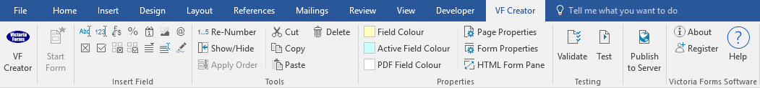

Please visit VictoriaForms.com/VF-Creator/ to start creating online forms in Word.

Request for P45 Form
Leaver’s Information
Position
Full Name
Home Address
Postcode
National Insurance Number
Email Address
Reason for Leaving
Last Date of Work

Reasons for Resignation

Declaration
I confirm that I am resigning from the above post
Signature |  | Date

