This Form was created in Word using VF Creator.
Created: 12/01/2018 by the VF Creator team.
VF Creator turns documents created in Word into online forms.

You can view/edit eForm features, after installing the VF Creator add-in. A new VF Creator ribbon will be available which allows you to create/edit eForms.

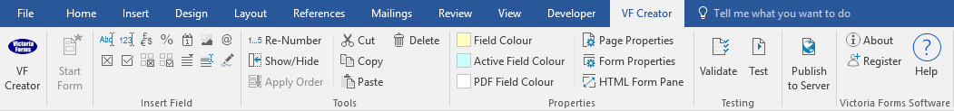

Please visit VictoriaForms.com/VF-Creator/ to start creating online forms in Word.

Application Form for rented property
Full name (Please print)
Contact telephone numbers
Email Address
Current Address (Please Print)
How long at this address?
Address prior to this
How long did you stay at this address?
Current Employment Details
Name of Employer
Address
How long have you been in this Employment?
Current Salary
If less than one year please give previous employment details
Have you ever lived in rented accommodation before?
Yes No
Please give details
Landlord’s Name & Address
Address of rented accommodation
How long did you rent this accommodation for?
Do you smoke?
Yes No
Do you have any pets?
Yes Please specify No
Do you have any medical disability?
Yes Please specify No
Two references are required to be submitted with your application for accommodation

