This Form was created in Word using VF Creator.
Created: 12/01/2018 by the VF Creator team.
VF Creator turns documents created in Word into online forms.

You can view/edit eForm features, after installing the VF Creator add-in. A new VF Creator ribbon will be available which allows you to create/edit eForms.

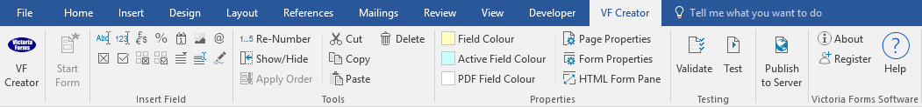

Please visit VictoriaForms.com/VF-Creator/ to start creating online forms in Word.

Recruitment Checklist
Name of vacancy
Number of vacancies
Planned start date
- Plan | Task done by | Date | Notes
Identify staff needed: Where, why and plan for the future
- Prepare | Task done by | Date | Notes
Consider whether any of the aims of the job have changed, and how this may affect factors such as the skills required and work flow

Compile documents for the vacancy:
- Job description
- Person specification
- Job application form
- Equality & diversity monitoring form
- Job offer letter template /Written Statement of Terms and Conditions of Employment
- Information about the employer
- Advertise | Task done by | Date | Notes
Before drawing up the job ad, decide factors such as how candidates should apply, who will sift applications and the rate of pay
Choose where to advertise in at least two different channels
Compile the job ad, carefully ensuring the wording is not discriminatory
- Handle applications | Task done by | Date | Notes
Send ‘application pack’ to applicants, including:
- application form
- job description
- person specification
- equality & diversity monitoring form
Using the job description, person specification and application forms, at least two people trained for the task should objectively draw up a shortlist of candidates for interview and/or further assessment
Invite shortlisted candidates for interview/ assessment, and ask whether they need any ‘reasonable adjustments’ for any part of the recruitment process
Get ready for the interviews, to be conducted by more than one person trained for the task:
- plan questions to probe skills and qualities essential for the job
- decide how candidates’ answers will be scored
- anticipate candidates’ questions and have the info ready
- plan any selection tests/ presentations etc and how they will be scored
- book a private room which will not be interrupted by telephone calls or visitors
Conduct the interview:
- briefly outline the job and the organization
- ask questions which cannot be answered ‘yes’ or ‘no’.
- listen and make brief notes
- check the candidate is familiar with the terms and conditions of the job, and finds them acceptable
- keep to the time frame for the interview, but allow for the candidate’s questions
- tell the candidate when they can expect to hear from the organisation
- explain that a job offer to the successful candidate will be subject to pre-employment checks
Select the best candidate for the job

- Complete | Task done by | Date | Notes
Final details
Send the successful candidate a job offer letter and explain pre-employment checks will have to be made
Make pre-employment checks such as the candidate’s right to work in the UK and references.
Resolve any employment contract queries
Before the recruit starts their new job:
- give them their Written Statement of Terms and Conditions of Employment to avoid disagreements or misunderstandings
- remind them where to find out about the organisation’s procedures and policies
Write to unsuccessful candidates and give feedback if requested

