This Form was created in Word using VF Creator.
Created: 12/01/2018 by the VF Creator team.
VF Creator turns documents created in Word into online forms.

You can view/edit eForm features, after installing the VF Creator add-in. A new VF Creator ribbon will be available which allows you to create/edit eForms.

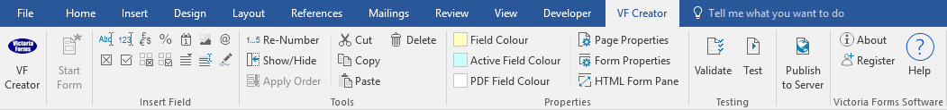

Please visit VictoriaForms.com/VF-Creator/ to start creating online forms in Word.

Property Inspection

This report should be used to record the condition of the accommodationn at the end of the period of tenancy. The Landlord and the Tenant should fill out this form together and agree on any action required.

Property:
Landlord(s):
Tenant(s):
Date of Inspection:

STATE code explanation:
S = satisfactory, N = needs attention – detailed action required

Entrance / hall | State | action Required
Walls/Ceiling/Woodwork
Floor/Coverings
Curtains/Blinds
Light Fittings/Power points
Windows/Doors/Screens
Comments/Other

LOUNGE | State | action Required
Walls/Ceiling/Woodwork
Floor/Coverings
Curtains/Blinds
Light Fittings/Power points
Windows/Doors/Screens
Comments/Other

dINING rOOM | State | action Required
Walls/Ceiling/Woodwork
Floor/Coverings
Curtains/Blinds
Light Fittings/Power points
Windows/Doors/Screens
Comments/Other

kitchen | STATE | action Required
Walls/Ceiling/Woodwork
Floor/Coverings
Curtains/Blinds
Light Fittings/Power points
Windows/Doors/Screens
Cupboards/Drawers
Bench tops/Tiling
Sink/Disposal Unit
Taps
Stove
Exhaust Fan
Comments/Other

BEDROOM 1 | State | action Required
Walls/Ceiling/Woodwork
Floor/Coverings
Curtains/Blinds
Light Fittings/Power points
Windows/Doors/Screens
Comments/Other

BEDROOM 2 | State | action Required
Walls/Ceiling/Woodwork
Floor/Coverings
Curtains/Blinds
Light Fittings/Power points
Windows/Doors/Screens
Comments/Other

BEDROOM 3 | State | action Required
Walls/Ceiling/Woodwork
Floor/Coverings
Curtains/Blinds
Light Fittings/Power points
Windows/Doors/Screens
Comments/Other

BATHROOM 1 | State | action Required
Walls/Ceiling/Woodwork
Floor/Coverings
Curtains/Blinds
Light Fittings/Power points
Windows/Doors/Screens
Bath
Shower
Shower Screen
Wash Basin
Tiling
Mirror/Cabinet
Towel rail
Toilet
Comments/Other

LAUNDRY | State | action Required
Walls/Ceiling/Woodwork
Floor/Coverings
Curtains/Blinds
Light Fittings/Power points
Windows/Doors/Screens
Wash Tubs
Comments/Other

eXTERIOR | State | action Required
Exterior Walls/Window frames
Lawns/Gardens
Roof/Gutters
Garage/Carport/Driveway
Clothes Line
Fences/Gates
Mailbox
Balcony/ Veranda/Porch
Outside lights
Doorbell/Security System
Comments/Other

OTHER COMMENTS

IMPACT ON TENANT AS A RESULT OF FAILING TO TAKE REQUIRED ACTION

Failure to take the required action as detailed above will result in deductions to the tenants bond to make good the repairs / cleaning required.

The cost of remedial action will be determined by obtaining two quotes to complete the work and selecting the lowest amount.

The amount to be deducted is estimated at:
(subject to receiving quotes)

NOTE: Given there is a need for action to be taken quickly, before the next staff member commences work, the availability of contractors may be limited and cost may be greater than expected.

ACKNOWLEDGEMENT

This report is a fair reflection of the of the state of the property and the action required to remedy the situation. (Do not sign unless you agree with all the details in the report.)

LANDLORD |  | TENANT
Name: |  | Name:
Signed: |  | Signed:
Date: |  | Date:

