This Form was created in Word using VF Creator.
Created: 24/01/2018 by the VF Creator team.
VF Creator turns documents created in Word into online forms.

You can view/edit eForm features, after installing the VF Creator add-in. A new VF Creator ribbon will be available which allows you to create/edit eForms.

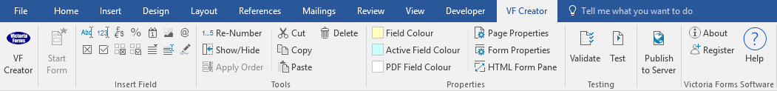

Please visit VictoriaForms.com/VF-Creator/ to start creating online forms in Word.

Pre-Employment Checklist

Name of prospective employee:
Their planned start date:

Checks framed by law | Check done by | Date | Notes
Identity. E.g. ask to see:
- original copies of their passport or driving licence
- a bank statement or utility bill to confirm their name and where they live
Right to work in UK
A Disclosure and Barring Service (DBS) check

Does the prospective employee need any special aids/ adaptations at work, whether or not s/he has a disability?
Does the prospective employee have a medical condition or disability which may affect his/her ability to carry out the proposed work?
Is the prospective employee having, or waiting for, treatment of any kind at present?
Has the prospective employee ever left a previous employment through ill-health or a work-related injury or condition?
Does the prospective employee have any back, neck or joint problems causing difficulty with standing, walking, bending, lifting and stair climbing?
Optional checks | Check done by | Date | Notes
References

Qualifications

