This Form was created in Word using VF Creator.
Created: 12/01/2018 by the VF Creator team.
VF Creator turns documents created in Word into online forms.

You can view/edit eForm features, after installing the VF Creator add-in. A new VF Creator ribbon will be available which allows you to create/edit eForms.

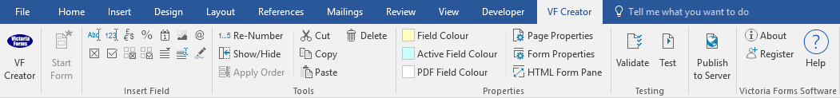

Please visit VictoriaForms.com/VF-Creator/ to start creating online forms in Word.

Dear ,
Following your recent interview, I am writing to offer you the post of at the salary of per year, starting on .

Full details of the post’s terms and conditions of employment are in your attached Written Statement of Terms and Conditions of Employment.

As explained at your interview, this job offer is made subject to satisfactory results from necessary pre-employment checks. There will also be a probationary period of which will have to be completed satisfactorily.

This is a
On starting, you will report to .

If you have any queries on the contents of this letter, the attached Written Statement of Terms and Conditions of Employment or the pre-employment checks, please do not hesitate to contact me on or .

To accept this offer, please sign and date the attached copy of this letter in the fields indicated and submit the letter online.

We are delighted to offer you this opportunity, and look forward to you joining the organisation and working with you.

This letter is part of your contract of employment.

Yours sincerely,

Signed

Name

