This Form was created in Word using VF Creator.
Created: 12/01/2018 by the VF Creator team.
VF Creator turns documents created in Word into online forms.

You can view/edit eForm features, after installing the VF Creator add-in. A new VF Creator ribbon will be available which allows you to create/edit eForms.

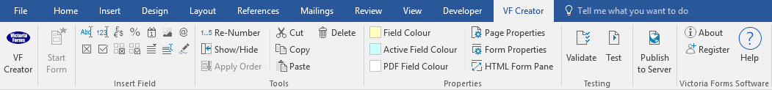

Please visit VictoriaForms.com/VF-Creator/ to start creating online forms in Word.

Job Application Form

Application for employment as:

Personal Information
Surname
Other names
Address
Postcode
Telephone

Education and training
Details and results of any examinations taken
Further education (e.g. technical college, evening classes)
Any craft or other training

Employment history
Present/previous employer
Address
Postcode
Job title
Duties
Rate of pay
Date employed | From |  | To
Reason for leaving
No approach will be made to your present employer before an offer of employment is made to you.
Please tell us about other jobs you have done and about the skills you used and/or learned in those jobs.

Please tell us why you applied for this job and why you think you are the best person for the jobs.
Do you consider yourself to have a disability?
Yes |  | No
Please tell us if there are any ‘reasonable adjustments’ we can make to assist you in your application or with our recruitment process.
Please tell us if there are any dates when you will not be available for interview.

Declaration
I can confirm that to the best of my knowledge the above information is correct. I accept that providing deliberately false information could result in my dismissal.
Signature |  | Date

