This Form was created in Word using VF Creator.
Created: 16/01/2018 by the VF Creator team.
VF Creator turns documents created in Word into online forms.

You can view/edit eForm features, after installing the VF Creator add-in. A new VF Creator ribbon will be available which allows you to create/edit eForms.

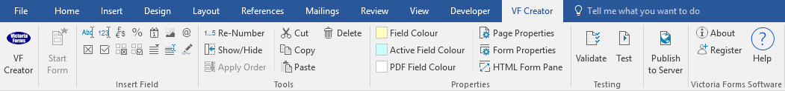

Please visit VictoriaForms.com/VF-Creator/ to start creating online forms in Word.

Employer Reference Request

Applicant:
Department:

The Applicant states that he/she was employed by you:

as from to
Please state:  Start Date: | Job Title:
Leave Date: | Reason for Leaving:
Referee:

Please give your assessment of applicant’s performance (tick appropriate boxes):
 | Excellent | Good | Satisfactory | Less than  Satisfactory | Unsatisfactory
Quality of work
Relationship
with colleagues
Communication
Attendance
Timekeeping

Number of days of sickness absence within the last 24 months:
Number of occasions:

During the course of his/her employment did you have any reason to doubt the applicant’s honesty?
YES NO

Subject to a suitable vacancy and policy permitting would you re-employ the applicant?
YES NO

Declaration

Signed |  | Date
Position

