This Form was created in Word using VF Creator.
Created: 12/01/2018 by the VF Creator team.
VF Creator turns documents created in Word into online forms.

You can view/edit eForm features, after installing the VF Creator add-in. A new VF Creator ribbon will be available which allows you to create/edit eForms.

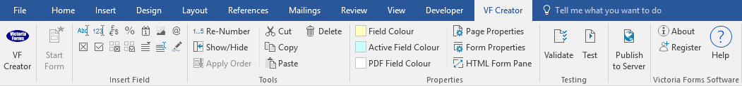

Please visit VictoriaForms.com/VF-Creator/ to start creating online forms in Word.

Driver Application Form

Please submit this form online once it has been completed.
Please note: VF Recruitment will only use this information to find you suitable work and will not share your details with any third parties.
*Fields marked with an asterisk are mandatory.
Personal Information
Full Name*
Address*
Postcode*
Telephone
Email*
Date of Birth* |  |  | NINO
Do you have permission to work in the UK?* | Yes |  | No
When can you start work?

Skills and Experience
Please detail trades you are experienced in. If you have no trade experience, please tell us what type of work you are interested in.*

Tickets
Please check all active tickets you currently hold*
SIA |  |  |  |  | PTS
CSCS |  |  |  |  | CTA
CSRS |  |  |  |  | Confined Space
CPCS Categories
A09 Forward Tipping Dumper |  |  |  |  | A10 180 Excavator below 10T
A12 180 Excavator above 10T |  |  |  |  | A14 Rough Terrain Forklift
A16 Industrial C/B Forklift Truck |  |  |  |  | A17 Telescopic Handler
A21 Wheeled Loading Shovel |  |  |  |  | A22 Tracked Loading Shovel
A23 Skid Steer Loader |  |  |  |  | A25 M.E.W.P. (scissor)
A26 M.E.W.P. (boom) |  |  |  |  | A31 Ride-on Road Roller
A32 Soil-landfill Compactors |  |  |  |  | A33 Agricultural Tractor
A34 Crawler Tractor/Dozer |  |  |  |  | A36 Lorry Loader
A39 Skip Handler |  |  |  |  | A56 Dump Truck Articulated
A57 Dump Truck Rigid Chassis |  |  |  |  | A58 360 Excavator below 10T
A59 360 Excavator above 10T
References
Please provide the details of two references below. If you are unable to provide two references please give the details of your previous employer.
 | Reference 1*
 | Name
 | Address
 | Town/City
 | Postcode
 | Telephone
 | Reference 2
 | Name
 | Address
 | Town/City
 | Postcode
 | Telephone

Additional Details
Please use this page to provide any additional details you think we should know about.

