This Form was created in Word using VF Creator.
Created: 12/01/2018 by the VF Creator team.
VF Creator turns documents created in Word into online forms.

You can view/edit eForm features, after installing the VF Creator add-in. A new VF Creator ribbon will be available which allows you to create/edit eForms.

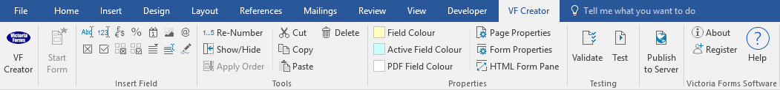

Please visit VictoriaForms.com/VF-Creator/ to start creating online forms in Word.

Curtailment of Maternity Leave and Pay (for Mother's Employer)
SECTION A: General
Please accept this as my notice to curtail my maternity leave and/or SMP. This form is accompanied by notification that either I intend to take SPL and/or ShPP or that my partner intends to take SPL and/or ShPP. I understand that my maternity leave will end on the date given in Section B and that my SMP will end on the date given in Section C. I understand that I can only reinstate my maternity leave if I revoke this notice before the curtailment date given in Section B. I understand that I can only reinstate any SMP that I am eligible for if I revoke this notice before the end date given in Section C.
Mother’s surname
Mother’s first name(s)
Child’s expected date of birth
Actual date of child’s birth (if born)
SECTION B: Curtailing maternity leave
Date statutory maternity leave started/is intended to start
Date statutory maternity leave will come to an end
Total number of weeks of statutory maternity leave that will have been taken at the date that statutory maternity leave ends
SECTION C: Curtailing maternity pay (only complete if claiming ShPP)
Date SMP started/is intended to start

Date SMP will come to an end
Total number of weeks of SMP that will have been paid at the date that SMP ends
SECTION D: Signature (must be completed)
Signature of mother
Date signed

Shared Parental Leave Form 1

