This Form was created in Word using VF Creator.
Created: 12/01/2018 by the VF Creator team.
VF Creator turns documents created in Word into online forms.

You can view/edit eForm features, after installing the VF Creator add-in. A new VF Creator ribbon will be available which allows you to create/edit eForms.

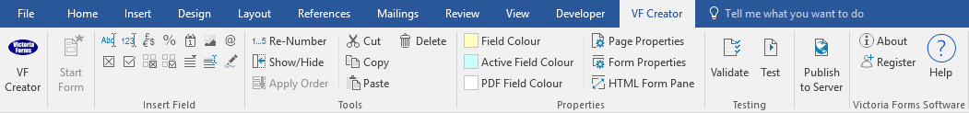

Please visit VictoriaForms.com/VF-Creator/ to start creating online forms in Word.

Staff Forms

Absence Request

Absence Information
Employee Name:
Employee Number:
Department:
Manager:

Type of Absence Requested:
 |  | Sick |  | Vacation |  |  | Bereavement |  |  |  |  | Time off without pay
 |  | Military |  | Jury Duty |  |  | Maternity/Paternity |  |  |  |  | Other
Dates of Absence: From: |  |  |  |  |  |  |  |  | To:

Reason for Absence:
You must submit requests for absences, other than sick leave, two days prior to the first day you will be absent.
Employee Signature | Date

