This Form was created in Word using VF Creator.
Created: 12/01/2018 by the VF Creator team.
VF Creator turns documents created in Word into online forms.

You can view/edit eForm features, after installing the VF Creator add-in. A new VF Creator ribbon will be available which allows you to create/edit eForms.

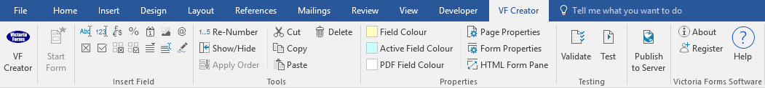

Please visit VictoriaForms.com/VF-Creator/ to start creating online forms in Word.

Employee / Applicant Monitoring Questionnaire
We are an Equal Opportunities Employer. We do not discriminate against our job applicants or employees and we aim to select the best person for the job. We monitor the community background and sex of our job applicants and employees in order to demonstrate our commitment to promoting equality of opportunity in employment and to comply with our duties under the Fair Employment & Treatment (NI) Oder 1998.

You are not obliged to answer the questions on this form and you will not suffer any penalty if you choose not to do so. Nevertheless, we encourage you to answer these questions. Your answers will be used by us to prepare and submit a monitoring return to the Equality Commission, but your identity will be kept anonymous. The information supplied is for monitoring purposes only and will be treated in strictest confidence. This form will not be used for recruitment selection purposes.

Full Name:
Post Applied For:
Date of Birth:
Gender: |  | Male |  | Female

Ethnicity
White
 | British |  | Irish |  |  | Any other white background
Black or Black British
 | Caribbean |  | African |  |  | Any other black background
Asian or Asian British
 | Indian |  | Pakistani |  |  | Bangladeshi
 | Any other Asian background
Chinese
 | Chinese |  | Any other ethnic group
Mixed
 | White and Black  Caribbean |  | White and Black African |  |  | White and Asian
 | Any other mixed background

Please specify:

Disability
Do you consider yourself to have a disability?

 | Yes |  | No

Religion
If you wish, you may disclose information about yourself in this section about your religion:

Have you ever been convicted of a criminal offence that is not spent under the Rehabilitation of Offenders Act 1974 (excluding fixed penalty points)?

 | Yes |  | No
If Yes, please provide details.

End of Questionnaire

