This Form was created in Word using VF Creator.
Created: 16/01/2018 by the VF Creator team.
VF Creator turns documents created in Word into online forms.

You can view/edit eForm features, after installing the VF Creator add-in. A new VF Creator ribbon will be available which allows you to create/edit eForms.

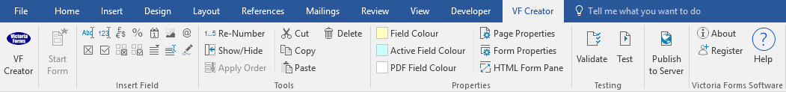

Please visit VictoriaForms.com/VF-Creator/ to start creating online forms in Word.

Candidate Expense Claim Form

To claim for expenses, please complete this form, attach scanned copies of receipts and supporting documents, and submit this form within 60 days of your recruitment event. Please note the following for smooth processing of claims:
1. All fields on this form are mandatory, unless otherwise specified.
2. Ensure accuracy and completeness of information provided to avoid delays in payment processing.

Personal Details
Surname
Forename
Address
Post code
County
Telephone number
Email address

Recruitment Event Details
Type of recruitment event
(e.g. Interview/Final Assessment/Exam)
Date of recruitment event
Location of recruitment event

Bank Details
Bank name
Bank account owner name
Bank account number
Sort code

Details of Travel Expenses Incurred
Please note the following:
1. Amount and currency indicated in the Expenses Details section should match receipts provided.
2. For mileage, use the following rates and indicate the number of miles travelled:
GBP 0.20 per mile

Date | From  (Post code) | To  (Post code) | Mode of Transport  (No. of miles if by car) | Amount
 |  |  | Travel Total:

Details of Receipted Expenditure

Date | Details of Expenditure |  |  | Amount
 |  |  | Travel Total:

Declaration
I declare that the above expenses were wholly, exclusively and necessarily incurred. You are advised to retain receipts to substantiate your expense claim for a period of 60 days or alternatively supply them to us for safe keeping.

Name:
Signature: |  | Date:

